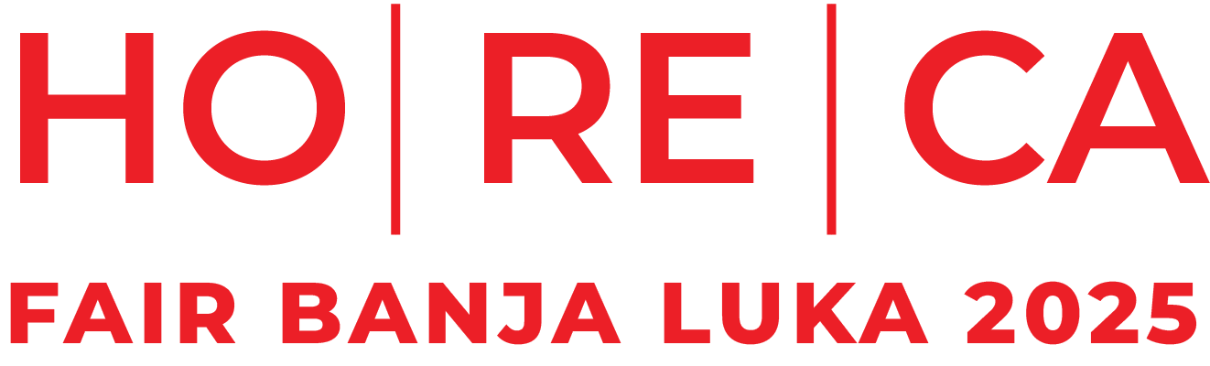

HoReCa FAIR BANJA LUKA 2025, 16-17. october – SC Borik Banja Luka

APPLICATION FORM
1. COMPANY DATA
NAME:
ADRESS:
ID: |  | VAT No:
HQ: |  | AUTHORIZED PERSON:
PHONE: |  | EMAIL:
CONTACT PERSON FOR FAIR: |  | PHONE:
EMAIL: |  | INDUSTRY SECTOR: |  |  |  |  | ☐ Hospitality Equipment & Technology  ☐ Food & Beverages  ☐ Hotel Industry & Hotel Equipment  ☐ Distribution & Logistics  ☐ Education & B2B Platforms  ☐ Catering & Event Industry
2. Details of the Rented Exhibition Space
☐ I am ordering a standard equipped booth – full setup |  |  |  | 85,00 EUR/m2 |  | SQUARE:
☐ I am ordering a standard equipped booth – basic setup |  |  |  | 75,00 EUR/m2 |  | SQUARE:
☐ I am ordering an unequipped exhibition space |  |  |  | 65,00 EUR/m2 |  | SQUARE:
*Note: Please select one of the offered booth setup options (FULL SETUP, BASIC SETUP, or UNEQUIPPED SPACE).
**FULL SETUP includes: one info counter, one table, four chairs, partition walls, carpet, fascia board with exhibitor’s name in block letters, 220V power outlet, and a waste bin.
***BASIC SETUP includes: carpet, partition walls, and a 220V power outlet.
****UNEQUIPPED EXHIBITION SPACE refers to floor space only, without any equipment or setup.
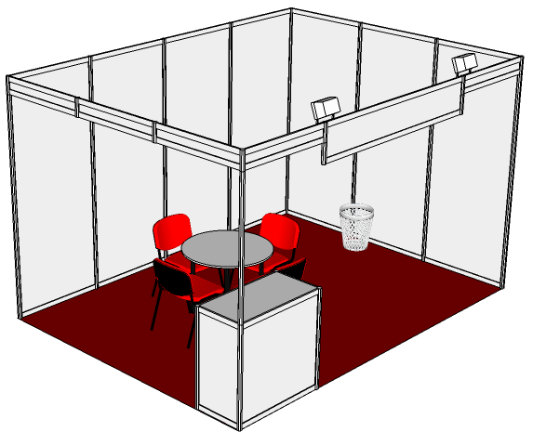 |  | 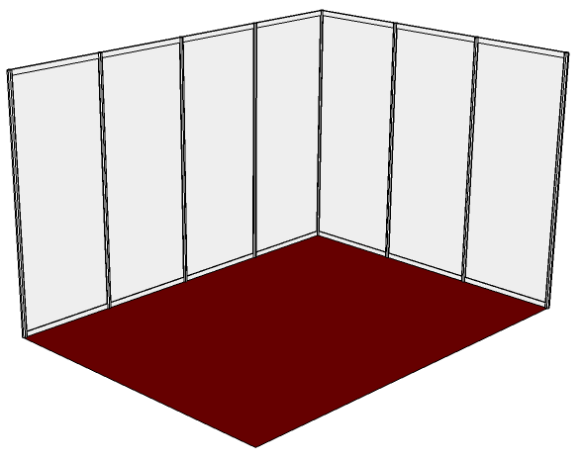
FULL SETUP |  | BASIC SETUP
3. Details of Special Booth Setup (Optional)
☐ I am ordering a premium equipped booth – full setup |  |  | 150 EUR/m2 |  | SQUARE:
☐ I am ordering a standard equipped booth – basic setup |  |  | On request |  | SQUARE:
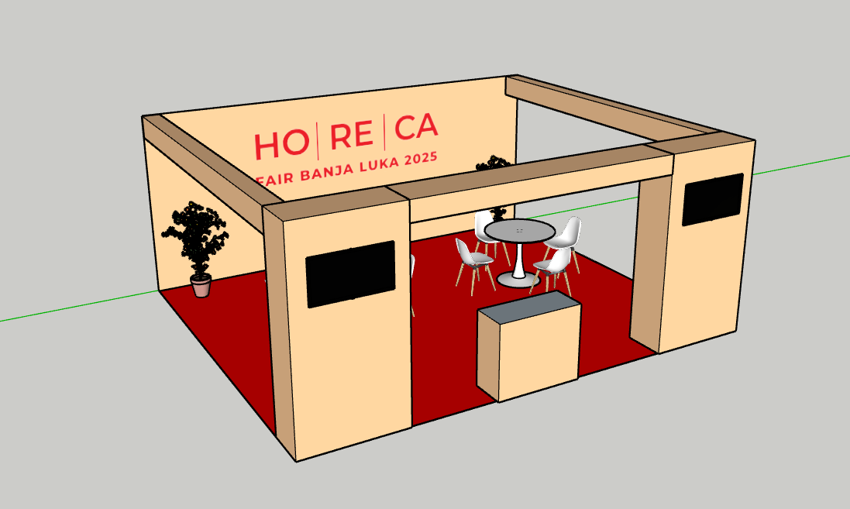 |  |  | 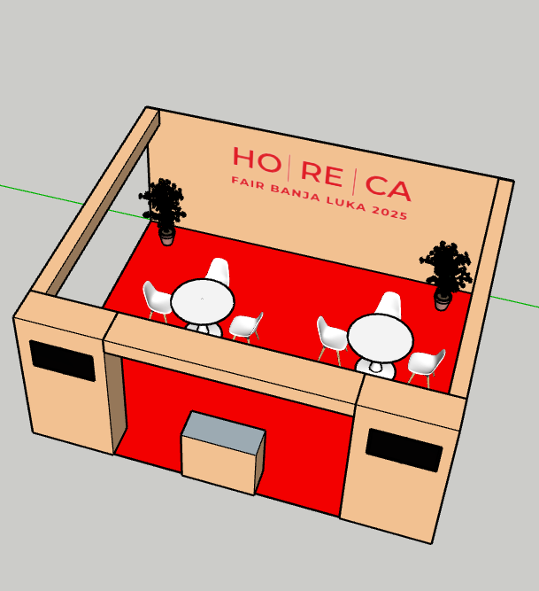
PREMIUM SETUP |  |  | PREMIUM SETUP
**PREMIUM SETUP includes: one info counter, two round tables, eight premium chairs, partition walls with LED lighting, carpet, fully branded booth in exhibitor's colors, 220V power outlet, two LCD TVs, decorative elements, and an attractive overall appearance.
4. Mandatory Exhibitor Registration Fee
The mandatory exhibitor registration fee includes a listing in the official fair catalogue “HoReCa FAIR BANJA LUKA 2025,” allocation of a certain number of accreditations based on the rented booth size, a short company description (up to 60 words), and the display of your logo on the official website www.horecafairbl.com with a link to your website. |  |  |  |  |  |  | 95,00 EUR

* We hereby declare that we agree with the terms specified in the fair application, as well as with the General Terms and Conditions of Participation at the “HoReCa FAIR BANJA LUKA,” which form an integral part of this application.

Date and place: | C.S. | ________________________________________________  Authorized person

Date and place: | C.S. | ________________________________________________  “HoReCa FAIR BANJA LUKA”

